Dr. D. Y. Patil Institute of Management and Entrepreneur Development


Project Report on
“COLLEGE NOTES MANAGEMENT SYSTEM”

Submitted By
Mr. Vishal Dnyaneshwar Sawai

Guided By
Prof. Harini Pawar

Submitted To
Dr. D. Y. Patil Institute of Management and Entrepreneur Development
Varale, Talegaon, Pune

INDEX

ACTIVITY  NO | DESCRIPTION | PAGE NO
1 | 1. Introduction  1.1 Existing System and Need for System  1.2 Scope of System  1.3 Operating Environment - Hardware and Software
2 | 2. Proposed System  2.1 Feasibility Study  2.2 Objectives of Proposed System  2.3 Users of System
3 | 3. Analysis And Design  3.1 System Requirements (Functional and Non-Functional requirements)  3.2 Entity Relationship Diagram (ERD)  3.3 Table Structure  3.4 Use Case Diagrams  3.5 Class Diagram  3.6 Activity Diagram  3.7 Deployment Diagram

INTRODCUTION
A College Notes Management System (CNMS) is a web application designed specifically for teachers in higher education institutions to manage and share class notes with their students. The purpose of this system is to provide an organized platform for teachers to store, manage, and distribute their class notes to students in an efficient and secure manner. With the CNMS, teachers can upload class notes, slides, and other educational materials, and students can easily access and download the materials. The CNMS is designed to be user-friendly, with a simple and intuitive interface that makes it easy for teachers to manage their notes and share them with their students. The system is also secure, with robust security measures in place to ensure that confidential information is protected from unauthorized access. Only teachers who have been granted access to the CNMS are able to upload and share notes, which means that students can be confident that the materials they are accessing are legitimate and accurate.

Existing System and Need for System
Existing System:

The existing system for college notes management typically involves the manual distribution of notes either in a physical format or via email. This can be time-consuming for teachers and may not be the most efficient method for students to access and organize their notes.

Need for System
There is a need for a web-based College Notes Management System (CNMS) that allows teachers to easily share and manage their notes with students. The system would provide a centralized platform for storing and organizing notes, making it easier for students to access and manage their course materials.

1.2 Scope of System
The College Notes Management System web application will provide students with the following features:
- Access to notes provided by their teachers
- Ability to organize notes by class, topic, and date
- Ability to search for specific notes
- Ability to download notes
- Only authorized teachers will be able to upload notes to the system
- Students will only have access to the notes that have been uploaded by their teachers

1.3 Operating Environment - Hardware and Software
Hardware:
- Laptop/Desktop
- It must be Pentium-4.
- It must have 128MB or above RAM capacity.
- Internet Connection.
- HDD: - 40GB
Software:
IDE: Eclipse
Operating System: Windows
Browser: Google Chrome/Microsoft Edge/Mozilla Firefo
Database: XAMPP Server
Technology/Language Used:
Front-end: HTML, CSS, JavaScript, Tailwind CSS
Back-end: JAVA, (JSP/Servlet)
Database: MySQL

2. Proposed System

2.1 Feasibility Study

2.2 Objectives of Proposed System
1. To provide an organized and centralized platform for teachers to upload and share their class notes with students.
2. To reduce the burden on teachers in terms of distributing class notes and reduce the risk of losing or misplacing physical copies of notes.
3. To enhance the learning experience for students by providing them with a comprehensive and easily accessible source of class notes.
4. To improve the security and privacy of class notes by providing a secure and controlled platform for sharing and storing them.
5. To reduce paper usage and promote sustainability by eliminating the need for printed class notes.
Overall, the proposed CNMS website aims to provide a convenient and efficient solution for managing class notes, enhancing the learning experience for students, and simplifying the work of teachers.

2.3 User Classes and Characteristics
Student Users
The primary users of the College Notes Management System web application will be students who are enrolled in classes at the college or university. This students will use the application to access notes provided by their teachers, organize their notes by class, topic, and date, search for specific notes.
Characteristics of Student Users
- The students will have a need to access notes provided by their teachers.
- The students will have a need to organize their notes by class, topic, and date.
- The students will expect a user-friendly interface that is easy to navigate.
- The students will expect the application to be accessible on any device with internet access.
- The students will expect the application to be secure and protect their privacy.
Teacher Users
The secondary users of the College Notes Management System web application will be the teachers who are responsible for providing the notes to the students. These teachers will have varying levels of technical expertise, but all will have access to a web browser. The teachers will use the application to upload notes to the system and monitor the access of the students to the notes.
Characteristics of Teacher Users
- The teachers will have a need to upload notes to the system.
- The teachers will have a need to monitor the access of the students to the notes.
- The teachers will expect a user-friendly interface that is easy to navigate.
- The teachers will expect the application to be secure and protect their privacy.
- The teachers will expect the application to be easy to use and understand.
- The teachers will expect the application to be efficient in uploading and monitoring the notes.

3. Analysis And Design

3.1 System Requirements (Functional and Non-Functional requirements)
Functional Requirements
- Admin portal
- Users will be able to login in the website using their email and password provided by admin
- Once logged in, users will be able to upload and download notes for different classes and subject
- Users will be able to mark notes as private or public.
- Users will be able to reset their password if they forget it.

Non-Functional Requirements
- The website will be designed to be responsive and accessible on all devices and screen sizes.
- The website will be designed with a clean and modern user interface.
- The website will be designed to be user-friendly and easy to navigate.
- The website will be designed to be secure and protect user data from unauthorized access and breaches.

3.2 Entity Relationship Diagram (ERD)

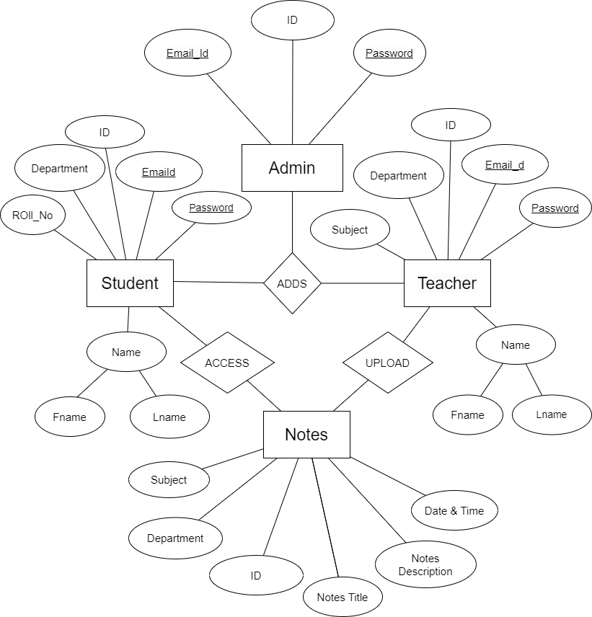

3.3 Table Structure

3.4 Use Case Diagrams

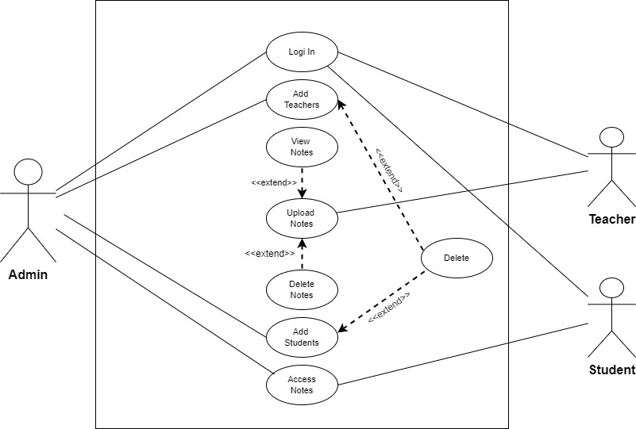

3.5 Class Diagram
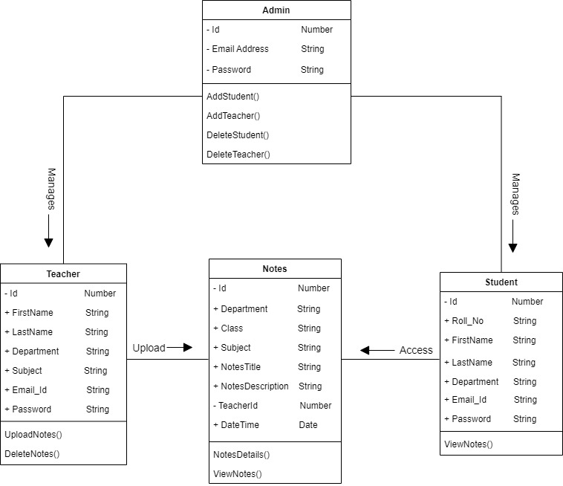

3.6 Activity Diagram
- Admin
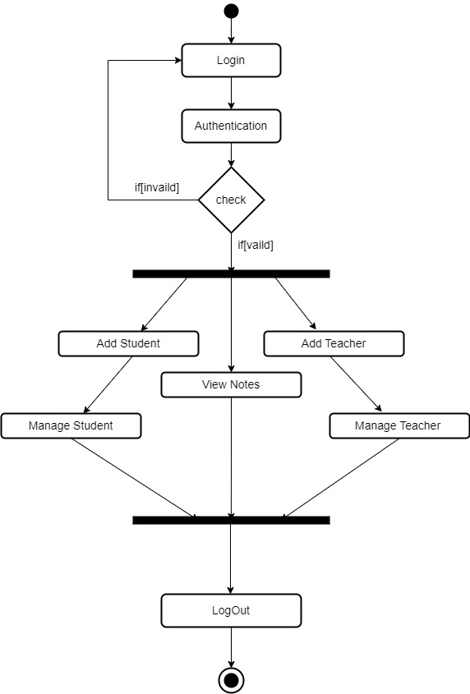

- Student
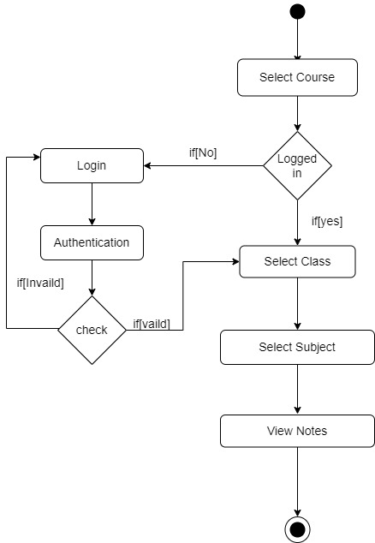

- Teacher
